Use the following steps to change the speed settings on a Gryphon:
- Open gryph_speeds.exe.
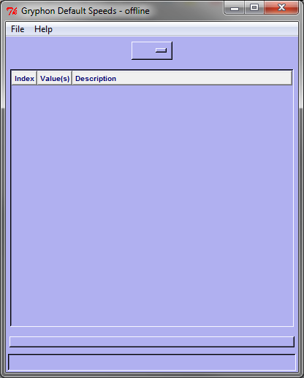
- Go to File -> Configuration to set the IP address of the Gryphon you want to connect to.
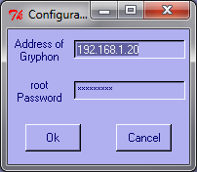
- Go to File -> Connect to <IPAddress> to connect to the Gryphon. (Sometimes the tool has difficulty connecting, in which case you just repeat this step to retry.)
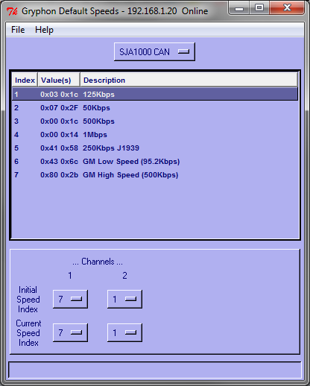
- Channel 1 normally has an index of 3 or 7, which are for 500Kbps. This does not need to change.
- Channel 2 should be set to 1, which is for 125Kbps. Do this for both the Initial Speed Index and the Current Speed Index.
- Go to File -> Save File. (The tool may also have difficulty saving the file, in which case an error box comes up. Just retry by repeating this step.)
- Go to File -> Disconnect from <IPAddress> to disconnect from the Gryphon.
- No reboot is necessary. You may continue to test vehicles right away.

